DATA STRUCTURES AND ALGORITHMS (CSC-221)

Instructor: Engr. SIDRA MUDASSAR

RULES:

**1)** **Within** **10** **mins** **after** **the** **start** **of** **class,** **attendance** **will** **be** **taken.**

**2)** **Follow** **the** **Dress** **code** **from** **Student** **Handbook**

**3)** **Use** **of** **Cell** **phones** **is** **PROHIBITED** **IN** **CLASS**

**TEXT** **BOOK:**

 ***DATA*** ***STRUCTURES*** ***BY*** ***SEYMOUR*** ***LIPSCHUTZ*** ***2014*** ***(LATEST)***

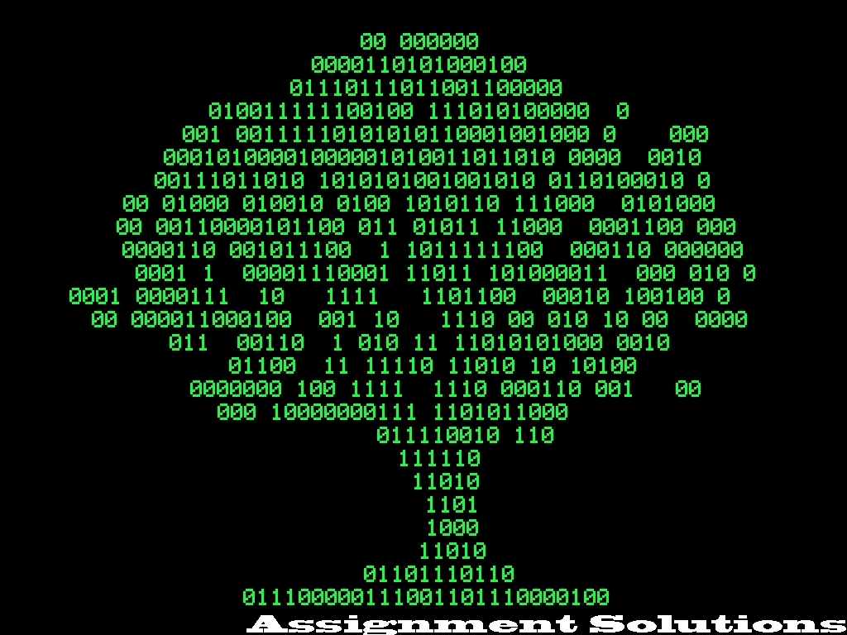

**DATA** **STRUCTURE:**

DATA: is a set of values of qualitative or quantitative variables

STRUCTURE: the arrangement of and relations between the parts or elements

**DATA** **STRUCTURE:** **Data** **structure** **is** **a** **particular** **way** **of** **organizing** **data** **in** **a** **computer** **so** **that** **it** **can**

◆

**be** **used** **efficiently**

**Data** **structure** **is** **a** **particular** **way** **of** **storing** **and** **organizing** **information** **in** **a** **computer** **so**

**that** **it** **can** **be** **retrieved** **and** **used** **most** **productively.**

◆

**NEED** **FOR**

**Data** **structures** **are** **important** **for** **the** **following** **reasons:**

**DATA** **STRUCTURES:**

**1.** **Data** **structures** **are** **used** **in** **almost** **every** **program** **or** **software** **system.**

**2.** **Specific** **data** **structures** **are** **essential** **ingredients** **of** **many** **efficient** **algorithms,** **and** **make** **possible** **the** **management** **of** **huge** **amounts** **of** **data,** **such** **as** **large** **integrated** **collection** **of** **databases.**

**3.** **Some** **programming** **languages** **emphasize** **data** **structures,** **rather** **than** **algorithms,** **as** **the** **key** **organizing** **factor** **in** **software** **design.**

**CHARACTERISTIC** **S** **OF** **DATA** **STRUCTURES:**

**1.** **It** **contains** **data** **items** **that** **can** **be** **elementary** **item,** **group** **item** **or** **another** **data** **structure.**

**2.** **It** **has** **a** **set** **of** **operations** **that** **can** **be** **performed** **on** **data** **items.** **Such** **as** **searching,** **insertion** **etc.**

**3.** **It** **describes** **the** **rules** **of** **how** **the** **data** **items** **are** **related** **to** **each** **other.**

**DATA** **STRUCTURE** **AND** **ALGORITHMS:**

 **Many** **algorithms** **apply** **directly** **to** **a** **specific** **data** **structures.** **When** **working** **with** **certain** **data** **structures** **you** **need** **to** **know** **how** **to** **insert** **new** **data,** **search** **for** **a** **specified** **item,** **and** **deleting** **a** **specific** **item.**

 **Commonly** **used** **algorithms** **include** **are** **useful** **for:**

• **Searching** **for** **a** **particular** **data** **item** **(or** **record).**

• **Sorting** **the** **data.** **There** **are** **many** **ways** **to** **sort** **data.** ***Simple*** ***sorting,*** ***Advanced*** ***sorting***

• **Iterating** **through** **all** **the** **items** **in** **a** **data** **structure.** ***(Visiting*** ***each*** ***item*** ***in*** ***turn*** ***so*** ***as*** ***to*** ***display*** ***it*** ***or*** ***perform*** ***some*** ***other*** ***action*** ***on*** ***these*** ***items)***

**ALGORITHM**

An algorithm is a set of rules for carrying out calculation either by hand or on a machine

An algorithm is a finite step-by-step procedure to achieve a required result

An algorithm is a sequence of computational steps that transform the input into the output.

An algorithm is a sequence of operations performed on data that have to be organized in data structures.

An algorithm is an abstraction of a program to be executed on a physical machine (model of Computation).

**The** **Classic** **Multiplication** **Algorithm**

 Multiplication, the American way

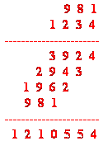 Multiply the multiplicand one after another by each digit of the multiplier taken from right to left.

**Multiplication** **Problem**

 Multiplication, the English way:

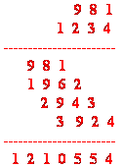 Multiply the multiplicand one after another by each digit of the multiplier taken from left to right.

PSEUDOCODE:

one of the commonly used tools to define algorithm is the pseudocode.

**Pseudocode** is an informal high-level description of the operating principle of a computer program or other algorithm

The pseudocode is an English like presentation of the code required for an algorithm.

Data Structure Classification

